Computer Architecture Lab
(EL-2012)
LABORATORY REPORT

Fall 2026

(Lab#04)
Use of Venus Simulator for Register Level Execution of RISC-V Arithmetic and Memory Instructions

Student Name: Huzaifa Kashif Roll No: 24I-6501 Section: CE-A

Date performed: 9/13/2026

MARKS AWARDED: ________ / 10

Signature and date of Instructor: _________________
Lab Instructors: Dr. Nasir Ali Shah, Engr. Fasih Ahmad

______________________________________________________________________________________________________________________________________________________

NATIONAL UNIVERSITY OF COMPUTER AND EMERGING SCIENCES, ISLAMABAD
Prepared by: | Fasih Ahmad |  | Version: 1.0
Verified by: | Dr. Nasir Ali Shah |  | Updated: Fall 2026

Task 1:

Description:
Here we had to do addition, subtraction, multiplication and exponent of 2. We used the keyword for instructions so add, sub, mult. I used s0 and s1 to store A and B. and s2-s5 to store the answers of the instructions.

Code:
addi s0,x0,5 # A
addi s1,x0,4 # B

add s2,s0,s1 # C = A+B
sub s3,s0,s1 # D = A-B
mul s4,s0,s1 # E = A*B
mul s5,s0,s0 # F= A*A = A^2

Output:
Step By Step Output:
A=5 – > addi s0,x0,5
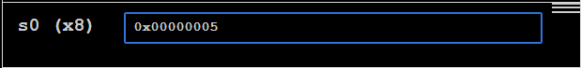
Adding 5 into x8 (s0) register which first saved register.
B = 4 —> addi s1,x0,4
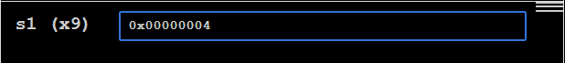

i) C= A+B —> add s2,s0,s1
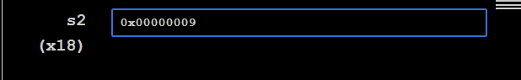
ii) D= A-B —> sub s3,s0,s1 # D = A-B
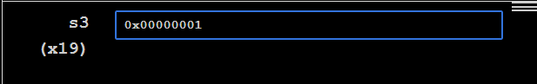
iii) E = A*B —> mul s4,s0,s1
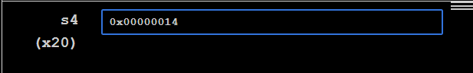
iv) F = A^2 —> mul s5,s0,s0
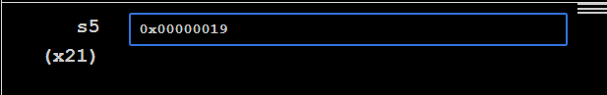
v)
Instruction | function7 | rs2 | rs1 | function3 | rd | opcode
add s2,s0,s1 | 0 | 9 | 8 | 0 | 18 | 51
sub s3,s0,s1 | 32 | 9 | 8 | 0 | 19 | 51
mul s4,s0,s1 | 1 | 9 | 8 | 0 | 20 | 51
mul s5,s0,s0 | 1 | 8 | 8 | 0 | 21 | 51

Task 2:

Description:
Here i defined the formula. I set a as s1, c as s2, d as s3, e as s4, f as s5 and finally m (result) as s0. To test the formula i intialized each register with a number. Using x0 and addi, i was able to set those constants.

Code:
#i will define registers here:
# a = s1,c=s2,d=s3,e=s4,f=s5 --- for m = s0

# to test if it work i will initalize each
addi s1, x0, 10
addi s2, x0, 3
addi s3, x0, 2
addi s4, x0, 4
addi s5, x0, 5

sub s0, s1,s2 #a-c
add s6, s3, s4 #d+e
mul s6, s6,s5 # (d+e)*f
add s0,s0,s6 # (a-c)+(d+e)*f

Output:
Initalizing all:
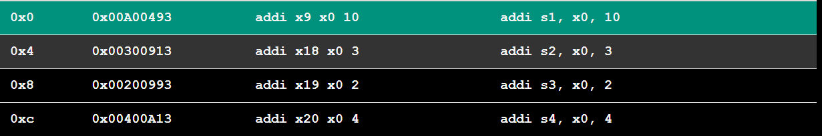

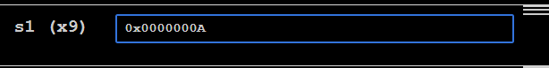
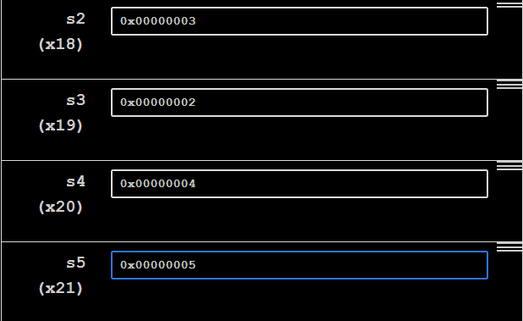
Now m = (a-c)+(d+e)*f

-> a-c
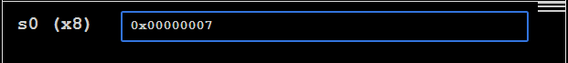
-> d+e
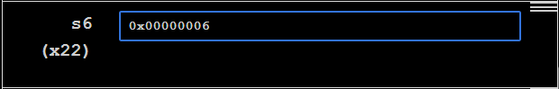
-> (d+e)*f
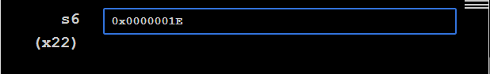
-> (a-c)+(d+e)*f
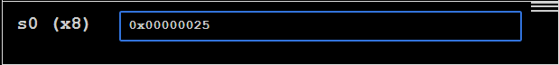

Since (10-3)+(2+4)*5 = 37. The hex 0x00000025 to decimal is 37.

Task 3:

Description:
Here i used li to set the registers with the specified hex address. Then i used the AND, OR, XOR keywords and compared the addresses with each other.

Code:
li s0, 0x00000fff #first number s0 = 0xfff
li s1,0x00000f0f #second number s1= 0xf0f
# reg s2 = AND, s3=OR, s4 = XOR
and s2,s0,s1
or s3,s0,s1
xor s4,s0,s1

Output:
Storing 0xfff:
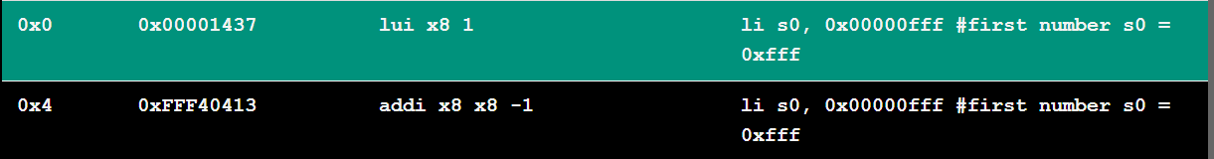
Storing 0xf0f
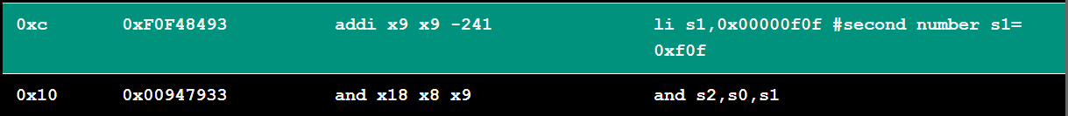

Then applying operators:

0xfff AND 0xf0f:
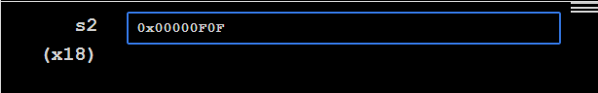
0xfff OR 0xf0f:
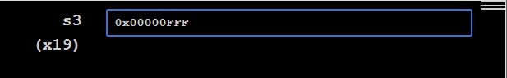

0xfff XOR 0xf0f:
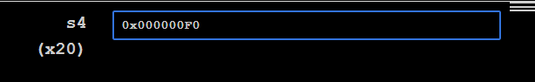

Task 4:

Description:
Here the problem was that you could not set numbers as the methods. So i set and renamed the for loop method called ‘1:’ as ‘loop’ and the 1: numbered method as ‘end’. I also used .word to set an array of 3 numbers.

Code:
.data
array: .word 10, 15, 20

.text
main:
la a0, array
li a1, 3

jal ra, arraysum
j done

arraysum:
# a0 = int a[]
# a1 = int size
# t0 = ret
# t1 = i
li t0, 0 # ret = 0
li t1, 0 # i = 0
loop: # For loop
bge t1, a1,end # if i >= size, break
slli t2, t1, 2 # Multiply i by 4 (1 << 2 = 4)
add t2, a0, t2 # Update memory address
lw t2, 0(t2) # Dereference address to get integer
add t0, t0, t2 # Add integer value to ret
addi t1, t1, 1 # Increment the iterator
j loop # Jump back to start of loop (1 backwards)
end:
mv a0, t0 # Move t0 (ret) into a0
ret # Return via return address register

done:
mv a1 , a0
li a0,1
ecall

Output:
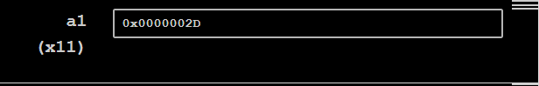

Task 5:

Description:
Here is used the .word keyword to set an array of numbers called table content. Then from s0- s9 i kept loading values from the array using the lw. To access a specific element in the array you had to set a specific offset. Since each element takes 4 bits. For tablecontent[0] you would give an offset of 0, tablecontent[1] you would give an offset of 4, tablecontent[2] you would give an offset of 8 ,and so on.

Code:
.data
tablecontent: .word 2, 4, 6, 8, 10, 12, 14, 16, 18, 20

.text

main:
la t0, tablecontent
# loading each with a 4 bit offset since table is an array into different registers
#ex. to access 6 we need to give it an offset of 8
lw s0, 0(t0)
lw s1, 4(t0)
lw s2, 8(t0)
lw s3, 12(t0)
lw s4, 16(t0)
lw s5, 20(t0)
lw s6, 24(t0)
lw s7, 28(t0)
lw s8, 32(t0)
lw s9, 36(t0)

Output:
